Open Mic-Share your talent: Opener-Jon Verdun
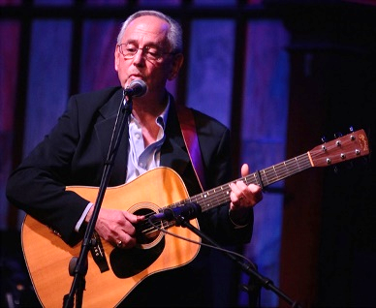
Songs-original or not
Instrumentals-original or not
Poetry- or not
Other spoken word-original or not
Other performance
Not just "folk"

